Noise Suppression in Ultrasound Beamforming Using Convolutional Neural Networks

By

Zhanwen Chen

Thesis

Submitted to the Faculty of the

Graduate School of Vanderbilt University

in partial fulfillment of the requirements

for the degree of

MASTER OF SCIENCE

in

Computer Science

December, 2019

Nashville, Tennessee

Approved: Date:

________________________________ _________

­Matthew Berger, Ph.D.

________________________________ _________

Maithilee Kunda, Ph.D.

To my parents, Cheng Yuehong and Chen Feng. Thank you for years of unconditional support and encouragement.

Chapter 1

BACKGROUND AND INTRODUCTION

* 1. *Ultrasound Beamforming*

Ultrasound is a widely used medical imaging modality. Compared with other imaging methods such as magnetic resonance imaging (MRI) and computed tomography (CT), ultrasound is affordable, noninvasive, and can characterize the cross-sectional view of soft tissues in real-time.

Delay-and-sum beamforming is a conventional method of forming images using ultrasound. A single ultrasonic transducer transmits and receive waves only along the depth dimension; an array of individual transducers can capture an additional lateral dimension. By applying time delays, we can focus every transducer in the array unto the same target (?).

If we denote the depth/axial dimension as D, the aperture domain (a subset of elements in the transducer array to use at the same time) as s, the lateral domain (the total number of elements in the transducer array), and the upsampling factor as up, we can describe the delay-and-sum processing in figure ?.



Figure 1 Delay-and-Sum Beamforming

* 1. *Convolutional Neural Networks*

Convolutional Neural Networks (CNNs) have seen widespread applications in Computer Vision, Natural Language Processing, and Medical Imaging alike. By taking advantage of localized parameter sharing, CNNs require fewer parameters and thus reduce the risk of overfitting. In our studies, we use CNNs for the same STFT-domain beamforming with similar performance but many fewer parameters, which makes them easier to train and less resource-intensive to deploy.

LeNet was the influential CNN architecture for classifying images. It consisted of two convolutional layers followed by two fully-connected layers. Each convolutional layer was accompanied by a pooling layer for down-sampling. Figure ? shows the architecture and hyperparameters of the original AlexNet. It was used to successfully recognize handwritten digits [cite].

AlexNet was another important architecture. Deeper than LeNet, it featured five convolutional layers. It was the first CNN to beat domain-specific methods to classify images in the ImageNet competition. To this day, AlexNet is still considered a reference architecture. Figure ? and table ? illustrate the model and its hyperparameters.

By applying CNNs to the same STFT data, we introduce convolution to the aperture dimension as well. CNNs could have the additional benefit of detecting local features such as aperture shapes. In addition, CNN beamformers, with fewer parameters, may be easier to train as shown in other application domains.

* 1. *Random Hyperparameter Search*

Traditionally, grid-search has been used to find the hyperparameters for the best-performing neural network model. However, recent studies show that a random approach may be more effective [cite].

* 1. *Neural Architecture Search (NAS)*

Similar to developments in hyperparameter search, there have been recent advances in heuristic search for model architectures, using Reinforcement Learning [cite], evolution [cite], and Bayesian methods [cite]. However, some studies suggest that NAS may not be outperforming random architecture search [cite]. Moreover, popular NAS libraries such as AutoKeras and NNI do not support regression tasks, only classification ones.

Chapter 2

RELATED WORK

2.1. *Neural-Network Beamforming*

Recently, deep neural networks have been used for ultrasound beamforming by our group [cite] and others [cite] [cite]. Our method applies deep neural network beamforming in the short-time Fourier transform (STFT) domain in order to avoid having to train for different pulse shapes, depth dependent attenuation, and other pulse parameters that may vary across patients and even across probes as they age. Our early approach used classic fully connected deep networks (FCNs) trained with synthetic data. These beamformers are convolutional in nature insofar as the networks, including their weights, are reused through depth; however, fully connected layers are used to span the aperture dimension. We demonstrated that these models could work well [cite].

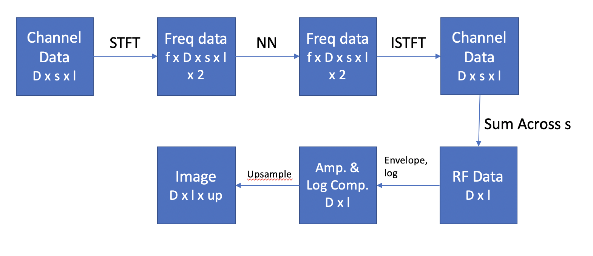

Figure Frequency-/Aperture-Domain DNN Beamforming

*2.2. CNN Beamforming*

Placeholder

Chapter 3

METHODS

3.1. *Training Data*

The FCN beamformer studied here was proposed previously by members of our group [cite]. A collection of FCN is trained to operate on channel data in the frequency domain. Training data was generated from Field II simulated point target responses [cite]. The simulated ultrasonic array was based on the L7-4 (38 mm) linear array transducer. Point targets were randomly placed in an annular sector centered at the focal depth of the transducer array, using a process that we have described previously [cite]. For the point targets inside the main lobe of the beam, the corresponding output was the same as the input; for those outside the main lobe of the beam, the corresponding output was a vector of zeros [cite]. We used 105 examples for training and 104 for validation.

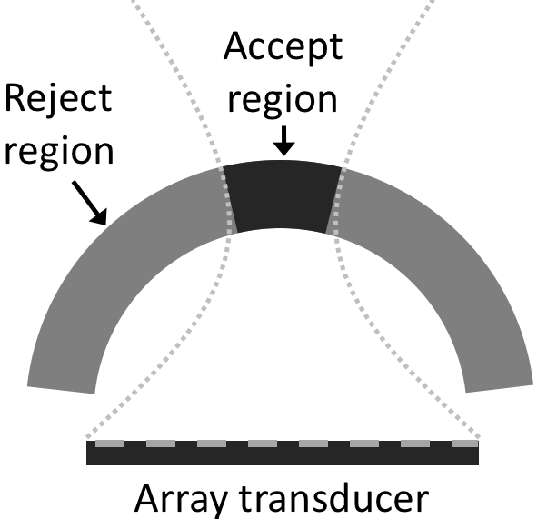

Figure 3 Scatterers were randomly placed along the annular sector as depicted. The acceptance region was taken as the region between the first nulls of a simulated beam. Question: Cite this figure? Not mine.

*3.2. Evaluation Scans*

An ATL L7-4 (38 mm) linear array transducer was operated using a Verasonics system to scan a physical phantom. A cylindrical cyst having 5mm in diameter located at 7cm depth was scanned using a cross-sectional view at five different positions along the axial dimension. The image quality metrics used for evaluation purposes included contrast-to-noise ratio (CNR), contrast ratio (CR), and speckle SNR.

*3.3. Convolutional Neural Networks*

Since there were no existing CNNs for our task, we had to design custom CNN architectures. The CNN architectures that we designed were based on LeNet [cite] and AlexNet [cite] because these architectures commonly serve as baselines for other applications. We implemented CNNs with configurable input, output, layer sizes, with and without pooling, kernel size, number of kernels, number of fully-connected layers, and many others, using similar layer types and layer orders. Figure ? shows an example LeNet-like CNN.



Figure An example single-channel, 1D LeNet-like CNN

We also varied the optimizers and loss functions. Optimizers were chosen between Stochastic Gradient Descent (SGD) and Adaptive Moment Estimation (Adam). Each model could have either Mean Squared Error (MSE), Mean Absolute Error (L1), or Smooth Mean Absolute Error (Smooth L1) as its loss function.

Our neural architecture search (NAS) consisted of 1000 trained models. They were random instead of heuristic, as current studies show that sophisticated NAS algorithms generally fail to outperform random search [cite]. In addition, studies show that random hyperparameter search outperformed grid search [cite]. Since popular NAS libraries such as AutoKeras and NNI lacked support for regression tasks, we created our own framework for random NAS using constraint satisfaction with Prolog. The models were created and trained with PyTorch [cite].

We investigated the effects of treating real and imaginary components as a flat array (1 by 130 by 1), as separate channels (1 by 65 by 2), and as a height dimension (2 by 65 by 1). We first concatenated the real and imaginery parts to have a single-channel 1D convolution. We then stacked the two parts as separate channels, resulting in a two-channel 1D convolution. Lastly, we treated inputs as narrow gray images that we convolve in both aperture and I-Q dimensions. Figure 3 compares all three groupings.



Figure 1D, single-channel convolution, (b) 1D, two-channel convolution, (c) 2D, 1-channel convolution

Chapter 4

RESULTS

4.1. *Best CNNs*

We found that LeNet-like CNNs featuring two convolutional layers and two or three fully-connected layers were effective. We also found that adding Gaussian noise in training was useful. Furthermore, it was better to concatenate the I and Q components as a single-channel 1D array or stack them as a two-channel 1D array than to stack them as a one-channel 2D array. Furthermore, almost all top-performing models used Adam instead of SGD as their optimizers. In terms of loss functions, L1 was ineffective compared with MSE and Smooth L1. Table 1 illustrates the architecture and hyperparameters of the best CNN. Figure 3 compares the beamformed images for the same phantom target processed by delay-and-sum, the best FCN, and the best CNN.



For phantom targets, the CNR was 5.46±0.45 dB, 5.57±0.20 dB, and 4.24±0.38 dB for the best CNN, the best FCN, and DAS, respectively. A t-test was used to compare the best CNN to the best FCN and the difference was not statistically significant (p-value=0.45). Our results suggest that CNNs produce equivalent results to FCNs and qualitative assessment suggests they may have a larger depth of field.

Based on the evaluation scans, we conclude that CNNs can match the performance of FCNs in suppressing off-axis scattering. In addition, CNNs have the added benefit of having fewer parameters, making training and deployment easier. Lastly, beamformed images indicate that CNNs may have a larger depth of field.

Chapter 5

DISCUSSIONS

*5.1. I/Q Groupings*

*5.2. Architectures*

*5.3. Visualize Convolution*

*5.4. Number of Weights*

Based on a t-test to compare the best CNN to the best FCN (p-value=0.45), we conclude that CNNs can match the performance of FCNs in suppressing off-axis scattering while having fewer parameters, making training and deployment easier. Figure 4 shows CNR as a function of model parameters, which confirms this trend.



Figure The best CNNs tend to use two magnitudes fewer weights than the best FCNs

REFERENCES

Y. LeCun, L. Bottou, Y. Bengio, and P. Haffner, ”Gradient-Based Learning Applied to Document Recognition,” Proceedings of the IEEE. 1998

A. C. Luchies and B. C. Byram, “Deep Neural Networks for Ultrasound Beamforming,” *IEEE Trans. on Med. Imag*., vol. 37, pp. 2010-2021, 2018

A. C. Luchies and B. Byram, “Training Improvements for Ultrasound Beamforming with Deep Neural Networks,” *Physics in Medicine and Biology*, vol. 64, no. 4, pp. 045018, 2019

Y. H. Yoon, S. Khan, J. Huh and J. C. Ye, ”Efficient B-Mode Ultrasound Image Reconstruction From Sub-Sampled RF Data Using Deep Learning,” in IEEE Transactions on Medical Imaging, vol. 38, no. 2, pp. 325-336, 2019